**DAILY ONLINE ACTIVITIES SUMMARY**

|  |  |  |  |  |  |  |  |  |
| --- | --- | --- | --- | --- | --- | --- | --- | --- |
| **Date:** | **17-06-2020** | | | | | **Name:** | **Anix Jugal D’Cunha** | |
| **Sem & Sec** | **8 sem , A sec** | | | | | **USN:** | **4AL16CS013** | |
| **Online Test Summary** | | | | | | | | |
| **Subject** | | **No Assessment was Conducted Today** | | | | | | |
| **Max. Marks** | | **--** | | **Score** | | | **--** | |
| **Certification Course Summary** | | | | | | | | |
| **Course** | **Variables In Java Coding** | | | | | | | |
| **Certificate Provider** | | | **Udemy** | | **Duration** | | | **1 hour** |
| **Coding Challenges** | | | | | | | | |
| **Problem Statement:** Java program to validate the identifiers using Regular Expression. | | | | | | | | |
| **Status: Competed** | | | | | | | | |
| **Uploaded the report in Github** | | | | | **yes** | | | |
| **If yes Repository name** | | | | | **alvas-education-foundation/dcunhaanixjugal** | | | |
| **Uploaded the report in slack** | | | | | **yes** | | | |

Online Test Details: (Attach the snapshot and briefly write the report for the same)

**No Assessment was Conducted Today**

Certification Course Details: (Attach the snapshot and briefly write the report for the same)

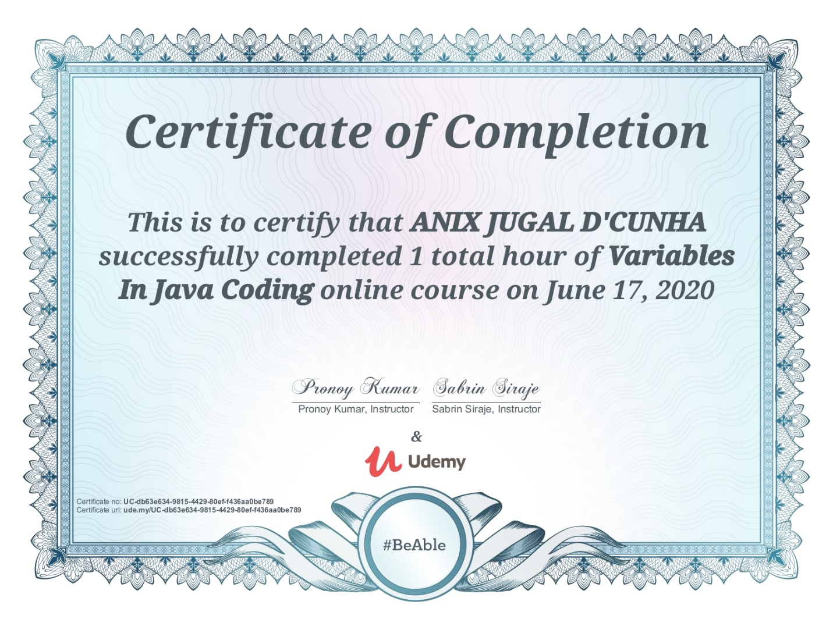

Coding Challenges Details: (Attach the snapshot and briefly write the report for the same)

Program-> Java program to validate the identifiers using Regular Expression.

import java.util.regex.*;

class GFG {

public static boolean

isValidIdentifier(String identifier)

{

String regex = "^([a-zA-Z_$][a-zA-Z\\d_$]*)$";

Pattern p = Pattern.compile(regex);

if (identifier == null) {

return false;

}

Matcher m = p.matcher(identifier);

return m.matches();

}

public static void main(String args[])

{

String str1 = "$geeks123";

System.out.println(isValidIdentifier(str1));

String str2 = "$gee ks123";

System.out.println(isValidIdentifier(str2));

String str3 = "1geeks$";

System.out.println(isValidIdentifier(str3));

}

}